Generalized Pareto distribution

Def

Parameter

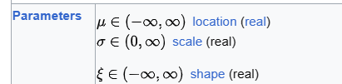

Support

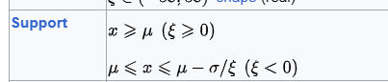

PDF

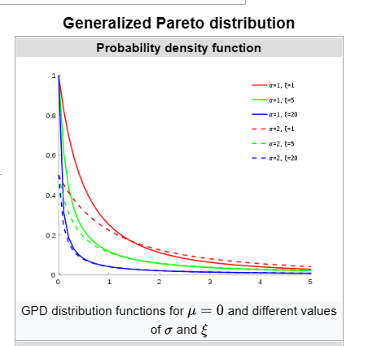

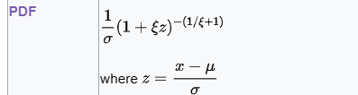

CDF

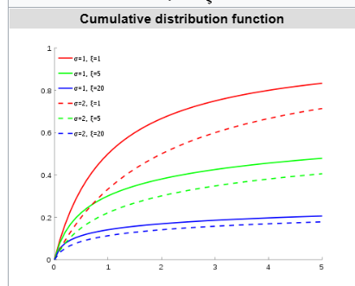



Expected Value



Variance



Median

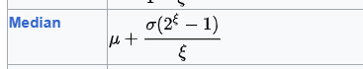

Mode



Skewness



Ex. Kurtosis

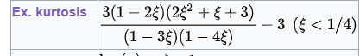

Entropy



MGF

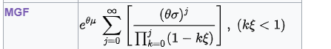

CF

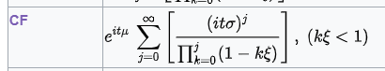

Moments

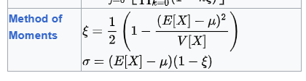

Special Case

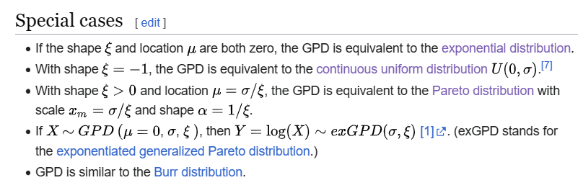

Ref

[Generalized Pareto distribution - Wikipedia](https://en.wikipedia.org/wiki/Generalized_Pareto_distribution)